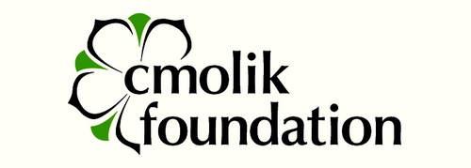School Based Scholarship Nomination

Part A: Personal Information

Your full name:

Address

City

Postal Code
Birthdate ( yyyy/mm/dd)
Number of years you have lived in BC

Part B: Applicant Questions
Questions are designed to help the school nomination committee determine if you are a suitable candidate for a TCF scholarship and meet the criteria being used for selection.
Educational Goals (50 words or less)
- What are your educational/academic goals? (Identify the degree you hope to obtain, the major you have selected, and the post-secondary institution you plan to attend.) Why did you choose this area of focus?

Clear Future Focus (100 words or less)
- What do you envision yourself doing ten years from now?

Faced Adversity (300 words or less)
- Describe for us a time when you or your family faced adversity. What was the adversity and the impact on your and/or your family?

Proven Resilience (300 words or less)
- Resilience is the ability to recover quickly from difficulties. Can you give us an example when you demonstrated resilience in your life?

Positive Work Ethic (300 words or less)
- Give us some examples of where you have demonstrated a positive work ethic?

Financial Need (300 words or less)
- In order to be eligible for a Cmolik Foundation you must have demonstrable financial need. Can you explain to us why you meet this criterion? And, how do you intend to support yourself through the years of your post-secondary education

Contribute to Community (Volunteerism) (300 words or less)
- In what ways have you made a positive contribution in your community (consider your school, family or local or broader community)?

Extra-Curricular Activities (200 words or less)
- Describe your extra-curricular activities, interests and/or achievements, including any paid work experience

Paying it Forward (25 words or less)
- If your application is successful, do you commit, during your lifetime, to help fund another student through TCF or otherwise, who is not related to you?

Resourcefulness (100 words or less)
- What resources have you leaned on in the past to help you through a challenging time?

